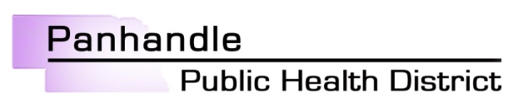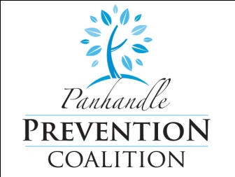

**Purpose** A smoke-free policy has been adopted to protect all employees and visitors from secondhand smoke, an established cause of cancer and respiratory disease. The policy set forth below is effective July 1, 2011 for [County]County Fair.

**Smoke-Free** The Livestock Pavilion is now smoke-free without exception**.**

**Areas** Smoking, including e-cigarettes, is not permitted anywhere on the fair grounds. [Smoking is permitted 15' from the entrance.]

**Sign** “No Smoking” signs must be clearly posted at all entrances and

**Requirements** other prominent places.

**Compliance** Compliance with the smoke-free livestock pavilion policy is mandatory for all employees and persons visiting, with no exceptions. Employees who violate this policy are subject to disciplinary action. Fai board members will monitor to ensure the fairgrounds remains smoke-free. Visitor can notify a fair board member if they wish to report a violation of the non-smoking policy.

**Questions**  Any questions regarding the smoke-free livestock pavilion policy should be directed to [fair office and phone number handling inquiries].

**[NOTE:** This policy may be modified for each county fair.]

For assistance adopting a smoke-free policy contact

Tabi Prochazka

(308) 487-3600, 107